Q1 self information, information rate and source entropy

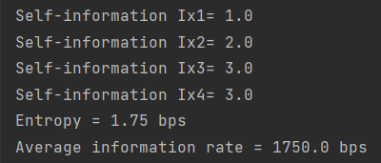import math  
Px1 = 0.5  
Px2 = 0.25  
Px3 = 0.125  
Px4 = 0.125  
rs=1000  
  
Ix1 = math.log(1/Px1,2)  
Ix2 = math.log(1/Px2,2)  
Ix3 = math.log(1/Px3,2)  
Ix4 = math.log(1/Px4,2)  
  
print("Self-information Ix1=",Ix1)  
print("Self-information Ix2=",Ix2)  
print("Self-information Ix3=",Ix3)  
print("Self-information Ix4=",Ix4)  
  
hx = (Px1*Ix1)+(Px2*Ix2)+(Px3*Ix3)+(Px4*Ix4)  
print("Entropy =",hx,"bps")  
  
R= hx*rs  
print("Average information rate =", R,"bps")

q2 channel capacity, bandwidth and snr

import math  
print('''Enter 1 for channel  
Enter 2 for Bandwidth  
Enter 3 for Snr\n''')  
a = int(input('Enter the number :-'))  
if a ==1:  
 B = float(input('Enter the Bandwidth ='))  
 snr = float(input('Enter the SNR ='))  
 C=B*math.log2(1+snr)  
 print('The Gaussian channel capacity is',C,'bps')  
elif a == 2:  
 C = float(input('Enter the Channel Capacity ='))  
 snr = float(input('Enter the SNR ='))  
 B = C/math.log2(1+snr)  
 print('The Bandwidth is',B,'Hz')  
elif a == 3:  
 C = float(input('Enter the Channel Capacity ='))  
 B = float(input('Enter the Bandwidth ='))  
 snr = 2**(C/B)-1  
 print('The snr is',snr)  
else:  
 print('Enter the valid number 1 2 3 ')  
print("Made By Varad Patil 120A2036")

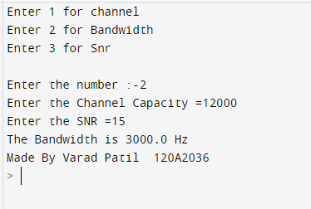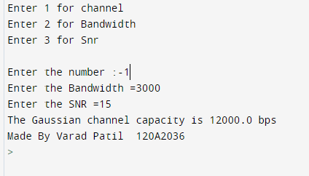

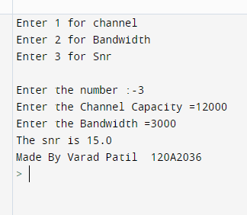

Q3 write a program for VRC generation and error detection

from operator import ixor  
import functools as f  
  
x = [1, 1, 1, 1, 0, 0, 0, 0]  
a = len(x)  
parity = f.reduce(ixor,x)  
x.append(parity)  
print('VRC-bit', parity)  
print('Transmitted Code', x)  
  
print('--'*25)  
i = 0  
while i < 2:  
 R = list(input('Enter the Recieved Code :-'))  
 R = list(map(int,R))  
 print('Recieved Code', R)  
 s = f.reduce(ixor,R)  
 print('--'*25)  
 if s == 0:  
 print('No error')  
 T = R[:a]  
 print('The data is', T)  
 elif s == 1:  
 print('1 bit error detected')  
 i = i + 1  
 print('--' * 25)

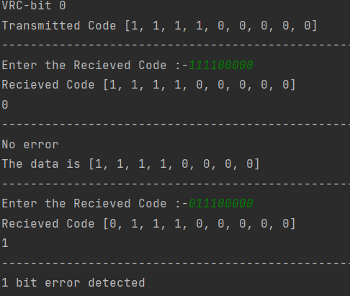

Q4 Write a program for HRC code generation and error detection.

x = [1, 1, 1, 1, 0, 0, 0, 0]  
n = 4  
  
"""Divide into n bits"""  
emp =[]  
for i in range(0, len(x), n):  
 emp.append(x[i:i + n])  
  
parity = list(a^b for a,b in zip(emp[0], emp[1]))  
  
T = x + parity  
print("HRC-Bit", parity)  
print('Transmitted code is',T)  
print('--'*25)  
  
while f<2:  
 r = list(input('Enter the Recieved Code :-'))  
 r = list(map(int, r))  
 """Spilt again"""  
 emp =[]  
 for i in range(0, len(r), n):  
 emp.append(r[i:i + n])  
   
 check = [0]*n  
 for i in range(len(emp)):  
 a3 = emp[i]  
 check = list(a ^ b for a, b in zip(check,a3))  
   
 if [0]*len(check) == check:  
 print('No error')  
 T1 = r[:-len(check)]  
 print('The data is', T1)  
   
 else:  
 print("EXOR sum", check)  
 print('error detected')  
 f = f+1

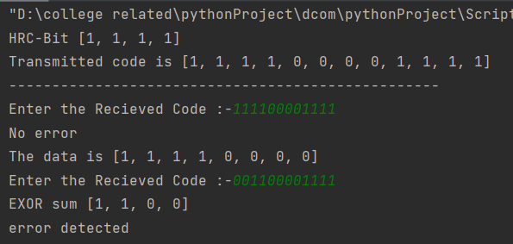

Q5 write a program for (6,3) codewords generation.

import numpy as np  
global c,t  
n = 6  
k = 3  
arr = 2 ** k  
a = []  
for i in range(0, arr):  
 b = bin(i)  
 b = b[2:]  
 b = b.zfill(k)  
 a.append(list(b))  
data = np.array(a, dtype=int)  
  
parity = n-k  
g = [[1, 0, 0, 1, 1, 0], [0, 1, 0, 0, 1, 1], [0, 0, 1, 1, 0, 1]]  
p = [item[-parity:] for item in g]  
  
g = np.array(g)  
rate = round(k/n,2)  
  
drow = data.shape[0]  
gcol = g.shape[1]  
  
if data.shape[1] == g.shape[0]:  
 c = np.zeros((data.shape[0], g.shape[1]), dtype=int)  
 for row in range(drow):  
 for col in range(gcol):  
 for elt in range(len(g)):  
 c[row, col] ^= data[row, elt] * g[elt, col]  
 c = np.array(c)  
  
num_of_ones = []  
  
for i in range(len(c)):  
 a = list(c[i]).count(1)  
 num_of_ones.append(a)  
num_of_ones.remove(0)  
  
dmin = min(num_of_ones)  
err_detect = dmin - 1  
if dmin%2 == 0:  
 print('dmin is an even number')  
 t = (dmin - 2)/2  
elif dmin%2 ==1:  
 print('dmin is an odd number')  
 t = (dmin - 1) / 2  
  
print('--'*100, end='\n')  
print('The DATA MATRIX IS :-')  
print(data)  
print('--'*100, end='\n')  
print('The GENERATOR MATRIX IS ')  
print(g)  
print('--'*100, end='\n')  
print('The CODE is :-')  
print(c)  
print('The minimum Hamming weight is = ', min(num_of_ones))  
print('The error detection capability :- ', err_detect)  
print('The error correction capability :- ', t)  
print('The Code rate is', rate)  
print('The Code efficiency is ', round(rate*100, 2))

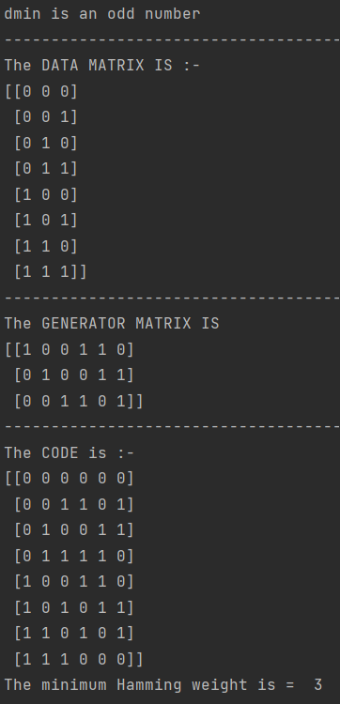

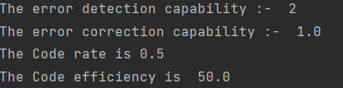

Q6 write a program for (7,4) codewords generation.

Code same hai as Q5 bas g ka value aur k,n ka value change kiya hai

import numpy as np  
global c,t  
n = 7  
k = 4  
arr = 2 ** k  
a = []  
for i in range(0, arr):  
 b = bin(i)  
 b = b[2:]  
 b = b.zfill(k)  
 a.append(list(b))  
data = np.array(a, dtype=int)  
  
parity = n-k  
g = [[1, 0, 0, 0, 1, 1, 1], [0, 1, 0, 0, 1, 0, 1], [0, 0, 1, 0, 0, 1, 1], [0, 0, 0, 1, 1, 1, 0]]  
p = [item[-parity:] for item in g]  
  
g = np.array(g)  
rate = round(k/n,2)  
  
drow = data.shape[0]  
gcol = g.shape[1]  
  
if data.shape[1] == g.shape[0]:  
 c = np.zeros((data.shape[0], g.shape[1]), dtype=int)  
 for row in range(drow):  
 for col in range(gcol):  
 for elt in range(len(g)):  
 c[row, col] ^= data[row, elt] * g[elt, col]  
 c = np.array(c)  
  
num_of_ones = []  
  
for i in range(len(c)):  
 a = list(c[i]).count(1)  
 num_of_ones.append(a)  
num_of_ones.remove(0)  
  
dmin = min(num_of_ones)  
err_detect = dmin - 1  
if dmin%2 == 0:  
 print('dmin is an even number')  
 t = (dmin - 2)/2  
elif dmin%2 ==1:  
 print('dmin is an odd number')  
 t = (dmin - 1) / 2  
  
print('--'*100, end='\n')  
print('The DATA MATRIX IS :-')  
print(data)  
print('--'*100, end='\n')  
print('The GENERATOR MATRIX IS ')  
print(g)  
print('--'*100, end='\n')  
print('The CODE is :-')  
print(c)  
print('The minimum Hamming weight is = ', min(num_of_ones))  
print('The error detection capability :- ', err_detect)  
print('The error correction capability :- ', t)  
print('The Code rate is', rate)  
print('The Code efficiency is ', round(rate*100, 2))

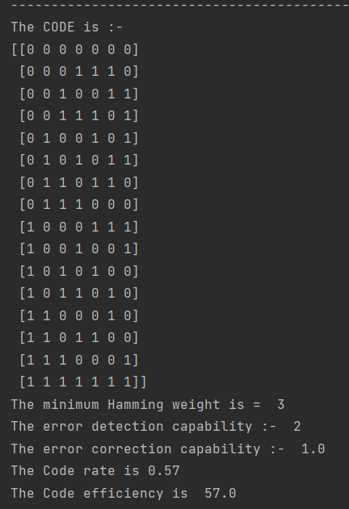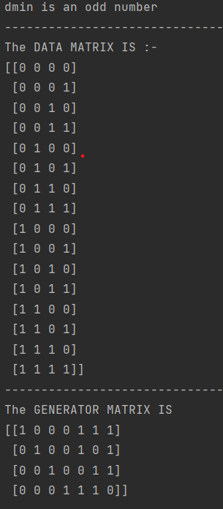

Q6 write a program for (7,4) Hamming code, error detection and correction.

import numpy as np  
global s  
n = 7  
k = 4  
g = [[1, 0, 0, 0, 1, 1, 0], [0, 1, 0, 0, 0, 1, 1], [0, 0, 1, 0, 1, 1, 1], [0, 0, 0, 1, 1, 0, 1]]  
  
"""H_matrix"""  
parity = n-k  
p = [item[-parity:] for item in g]  
pt = np.transpose(p)  
I = np.identity(n - k, dtype=int)  
  
I = list(map(list, I))  
pt = list(map(list, pt))  
  
h = []  
  
for i in range(n - k):  
 a = pt[i] + I[i]  
 h.append(a)  
  
"""Decoding """  
"""error codes"""  
emp1 = []  
e = [1] + [0]*(n-1)  
for i in range(n):  
 a = np.roll(e,i)  
 a = list(a)  
 emp1.append(a)  
emp1.append([0]*n)  
  
  
ht = np.transpose(h)  
ht = list(map(list,ht))  
a = [0]*parity  
ht.append(a)  
  
w = 0  
"""syndrome check"""  
while w < 3:  
 print('For ',w,'-bit error')  
 r = list(input('Enter the recieved code:-'))  
 r = list(map(int,r))  
 ht = list(map(list, ht))  
 s = []  
 emp = []  
 for i in range(len(r)):  
 if r[i] == 1:  
 s.append(ht[i])  
 list1 = [0] * len(ht[0])  
  
 for i in range(len(s)):  
 list2 = s[i]  
 emp = [a ^ b for a, b in zip(list1, list2)]  
 list1 = emp  
 if emp == [0] * parity:  
 print('No error')  
 print(r)  
  
 elif emp != [0] * parity:  
 err = []  
 for i in range(len(ht)):  
 if emp == ht[i]:  
 err = emp1[i]  
 print('for Syndrome =', emp, 'the error code is', err)  
  
 print('The error is in ', err.index(1) + 1, '-bit')  
 C = [a ^ b for a, b in zip(err, r)]  
 print('The corrected code is', C)  
  
 w = w +1  
 print('--' * 50, end='\n')

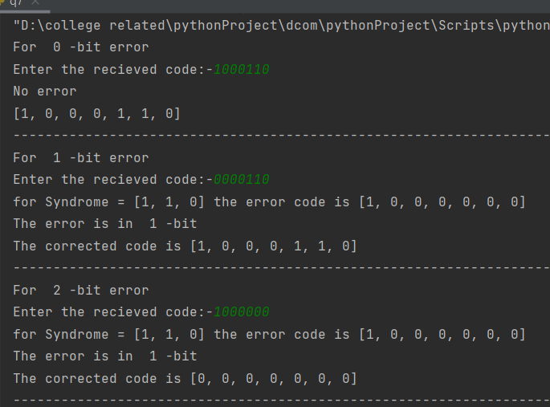

Q 8 Write a program for generating nrz unipolar code for the data 001101

from matplotlib import pyplot as mt  
  
"In a i have written the input data "  
a = [0, 0, 1, 1, 0, 1]  
a.append(0) # i added zero so that the graph ends at 0  
t = list(range(0,len(a)))  
  
"""NRZ Unipolar"""  
mt.step(t, a ,where='post') # ye square bananae ke liye hai  
mt.grid(True, which='both')  
mt.xlim(0, len(a)) # ye x axis ke scale hai graph ke  
mt.ylim(-0.1, 1.1) # ye y axis ke scale hai graph ke  
mt.title('NRZ Unipolar') #ye graph ka title hai  
  
mt.show() # ye line important hai iske bina graph nahi ayega

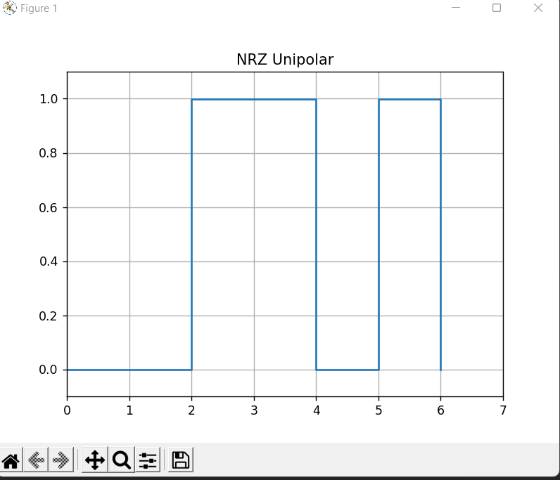

Q 9 Write a program for generating rz unipolar code for the data 001101

from matplotlib import pyplot as mt  
"In a i have written the input data "  
a = [0, 0, 1, 1, 0, 1]  
a.append(0) # i added zero so that the graph ends at 0  
t = list(range(0, len(a)))  
  
"""RZ Unipolar"""  
"""RZ UNIPOLAR me 1 ke liye graph half time hota"""  
emp = [] #ye empty list for amplitude  
empt = [] # empty list for time  
for i in range(len(a)):  
 if a[i] == 1:  
 b = i + 0.5  
 empt.append(b)  
 emp.append(1)  
 emp.append(0)  
 else:  
 emp.append(0)  
T = sorted(t + empt)  
  
"""YE Lines GRAPH SHOW KAREGA JO same hoga almost sabme"""  
mt.step(T, emp ,where='post') # ye square bananae ke liye hai  
mt.grid(True, which='both')  
mt.xlim(0, len(a)) # ye x axis ke scale hai graph ke  
mt.ylim(-0.1, 1.1) # ye y axis ke scale hai graph ke  
mt.title('RZ Unipolar') #ye graph ka title hai  
mt.show() # ye line important hai iske bina graph nahi ayega

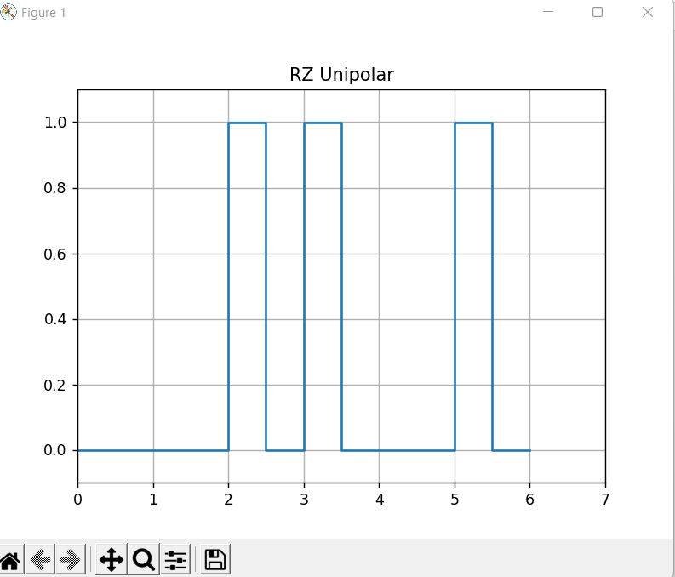

Q 10 Write a program for generating nrz polar code for the data 001101

*"""RZ unipolar me 0 and 1 ke place me -5 and 5 aise hota hai"""*from matplotlib import pyplot as mt  
  
"In a i have written the input data "  
a = [0, 0, 1, 1, 0, 1]  
a.append(0) # i added zero so that the graph ends at 0  
t = list(range(0, len(a)))  
volt = 5 # yaha pe voltage dalo  
  
"""NRZ Unipolar"""  
for i in range(len(a)):  
 if a[i] == 1:  
 a[i] = volt  
 else:  
 a[i] = -volt  
  
"""YE Lines GRAPH SHOW KAREGA JO same hoga almost sabme"""  
mt.step(t, a ,where='post') # ye square bananae ke liye hai  
mt.grid(True, which='both')  
mt.xlim(0, len(a)) # ye x axis ke scale hai graph ke  
mt.ylim(-volt-1, volt+1) # ye y axis ke scale hai graph ke  
mt.axhline(y=0,color = 'black') #ye line nahi likha to bhi chalega  
mt.title('RZ Unipolar') #ye graph ka title hai  
mt.show() # ye line important hai iske bina graph nahi ayega

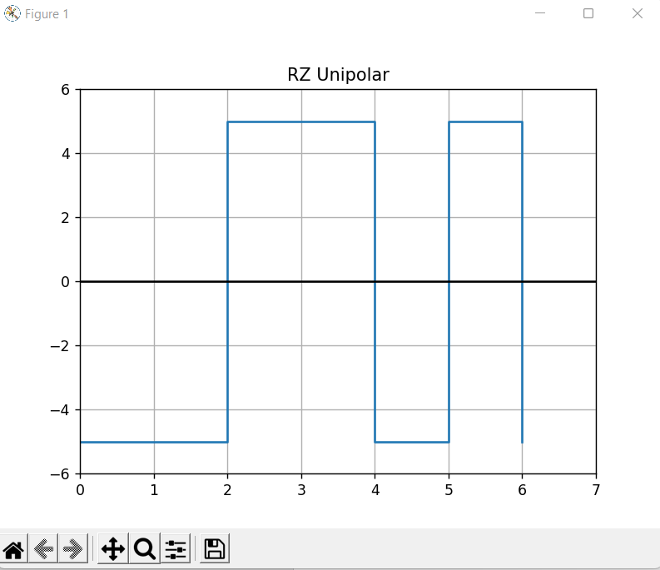

Q 11 Write a program for generating rz polar code for the data 001101

from matplotlib import pyplot as mt  
import numpy as np  
"In a i have written the input data "  
a = [0, 0, 1, 1, 0, 1]  
volt = 5 # yaha pe voltage dalo  
  
"""convert 0 and 1 to -5 and 5"""  
for i in range(len(a)):  
 if a[i] == 1:  
 a[i] = volt  
 else:  
 a[i] = -volt  
  
"""RZ polar"""  
"""RZ POLAR me 1 ke liye graph half time hota"""  
emp = [] #ye empty list for amplitude  
 # empty list for time  
for i in range(len(a)):  
 if a[i] == volt:  
  
 emp.append(volt)  
 emp.append(0)  
 else:  
 emp.append(-volt)  
 emp.append(0)  
T = list(np.arange(0,len(a)+0.5, 0.5))  
emp.append(0) # i added zero so that the graph ends at 0  
"""YE Lines GRAPH SHOW KAREGA JO same hoga almost sabme"""  
mt.step(T, emp ,where='post') # ye square bananae ke liye hai  
mt.grid(True, which='both')  
mt.xlim(0, len(a)) # ye x axis ke scale hai graph ke  
mt.ylim(-volt-1, volt+1) # ye y axis ke scale hai graph ke  
mt.title('RZ Unipolar') #ye graph ka title hai  
mt.show() # ye line important hai iske bina graph nahi ayega

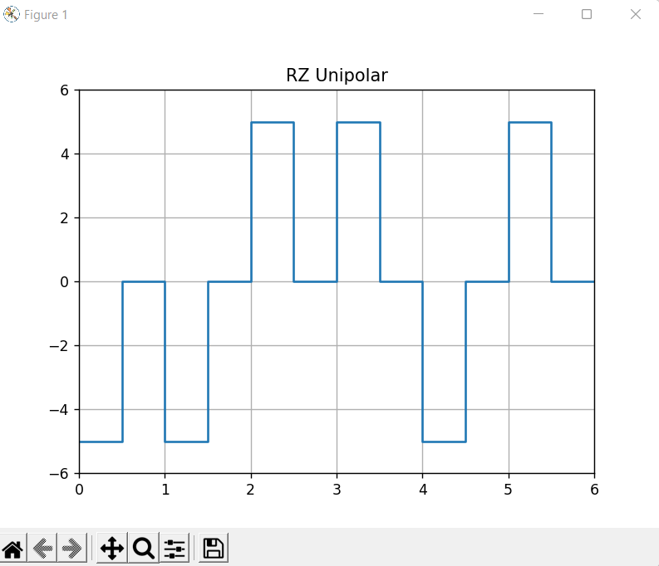

Q 12 Write a program for generating nrz AMI code for the data 001101

from matplotlib import pyplot as mt  
  
"In a i have written the input data "  
a = [0, 0, 1, 1, 0, 1]  
a.append(0) # i added zero so that the graph ends at 0  
volt = 5 # yaha pe voltage dalo  
t = list(range(0,len(a)))  
  
"""AMI me even number of volt or 1 covert hota hai volt or-1"""  
n = []  
for i in range(len(a)):  
 if a[i] == 1:  
 a[i] = volt  
 n.append(i) #n me 1 hai unke position ke saath  
  
for j in range(1,len(n)):  
 if j%2 == 1: #agar even 1 mila to usko inverse kar  
 a.pop(n[j])  
 a.insert(n[j],-volt)  
  
"""YE Lines GRAPH SHOW KAREGA JO same hoga almost sabme"""  
mt.step(t, a ,where='post') # ye square bananae ke liye hai  
mt.grid(True, which='both')  
mt.xlim(0, len(a)) # ye x axis ke scale hai graph ke  
mt.ylim(-volt-1, volt+1) # ye y axis ke scale hai graph ke  
mt.title('RZ Unipolar') #ye graph ka title hai  
mt.show() # ye line important hai iske bina graph nahi ayega

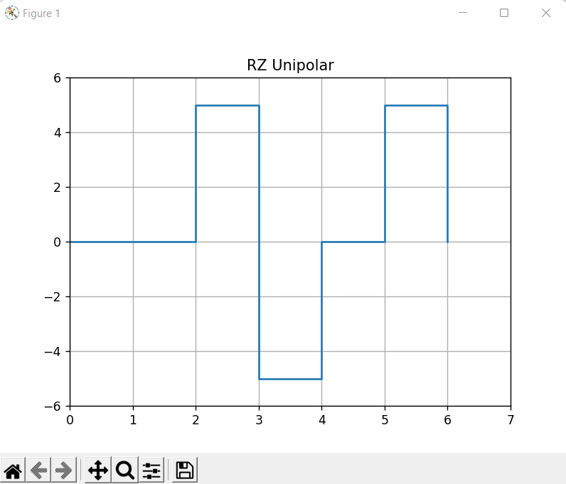

Q 13 Write a program for generating Manchester code for the data 001101

from matplotlib import pyplot as mt  
import numpy as np  
"In a i have written the input data "  
a = [0, 0, 1, 1, 0, 1]  
volt = 5 # yaha pe voltage dalo  
  
"""convert 0 and 1 to -5 and 5"""  
for i in range(len(a)):  
 if a[i] == 1:  
 a[i] = volt  
 else:  
 a[i] = -volt  
  
  
"""MAchester ka code lines"""  
emp = []  
for i in range(len(a)):  
 if volt == a[i]:  
 emp.append(volt)  
 emp.append(-volt)  
 elif -volt == a[i]:  
 emp.append(-volt)  
 emp.append(volt)  
  
T = list(np.arange(0,len(a)+0.5, 0.5))  
emp.append(0) # i added zero so that the graph ends at 0  
"""YE Lines GRAPH SHOW KAREGA JO same hoga almost sabme"""  
mt.step(T, emp ,where='post') # ye square bananae ke liye hai  
mt.grid(True, which='both')  
mt.xlim(0, len(a)) # ye x axis ke scale hai graph ke  
mt.ylim(-volt-1, volt+1) # ye y axis ke scale hai graph ke  
mt.title('RZ Unipolar') #ye graph ka title hai  
mt.show() # ye line important hai iske bina graph nahi ayega

